What is a Reflective Journal?

A reflective journal is a way of thinking in a critical and analytical way about your work in progress. It shows how different aspects of your work interconnect.
The journal may record:
- where your inspiration comes from
- how you make use of your ideas to develop your work
- your awareness of the cultural context (setting) in which you work

This context may include other people’s ideas and preferences, communities and practices, work practices, ideas of critics and theorists; social, political, aesthetic, ideological contexts and so forth.
The journal may include:
- research notes
- personal comments on your own work
- notes/images from site visits
- quotes
- extracts from workshops, events, training, books, journals
- photos/sketches
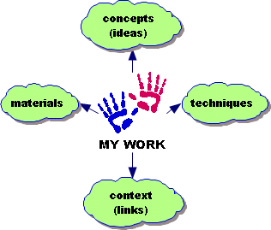

Reflective Writing

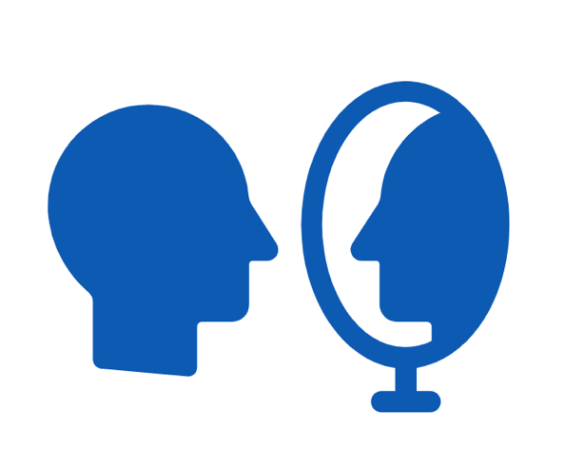
Reflective writing is evidence of looking back at an event, idea, object, experience, process, etc.
It involves:
- analysing and commenting on the object, process, and so forth from different points of view using contemporary ideas and theories
- exploring and explaining the importance or relevance of the object, process, and so forth
- considering things that went wrong as well as successes
- saying what the object, process, and so forth means to you
- saying how your learning will influence the way you work and/or make decisions in the future

Reflective Journal Structure
Notes are in grey italics to guide your writing.
When writing your reflective journal please use this template structure for each individual reflective entry you make. Over time you will have a rich resource to refer to into the future!
Date:

Purpose of reflection:

Description
Don’t make this too long but describe what it is/what happened/why am I talking about it

Interpretation
What is important, relevant, interesting, useful, how is it like or different from other opinions or considerations, how can it be explored, explained using contemporary theories or ideologies

Outcome
What have I learned from this activity, experience and how will it influence my future work, attitude, behaviour

End of Journal Entry

